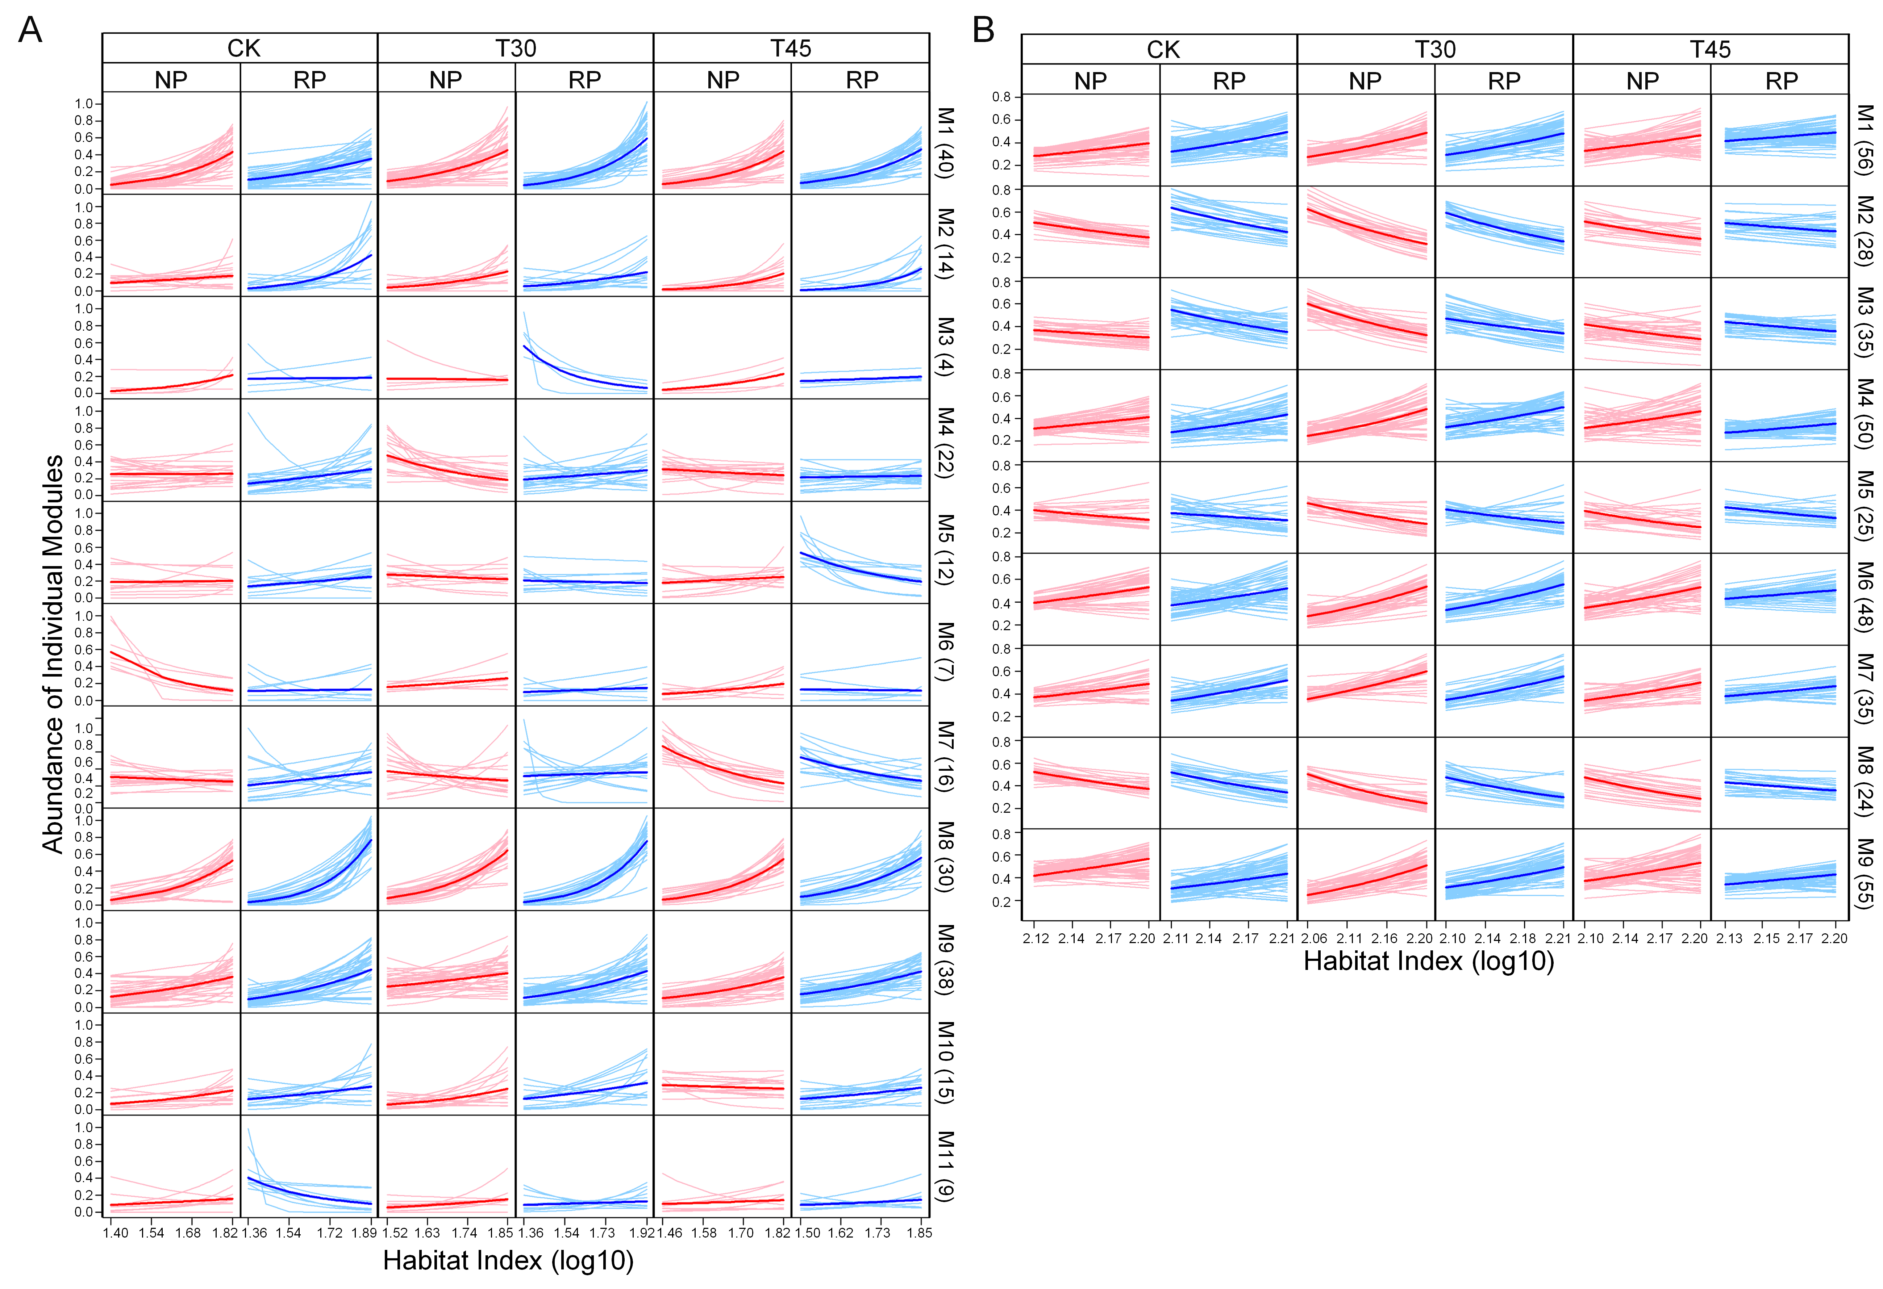

**Figure S1**. Microbial abundance curves are classified into 11 distinct modules (M1-M11) for the fungal community (**A**) and nine distinct modules (M1-M9) for the bacterial community (**B**) by six-dimensional functional clustering, under the combination of NP and RP with CK, T30, and T45. Numbers of OTUs within each module are given in parentheses.

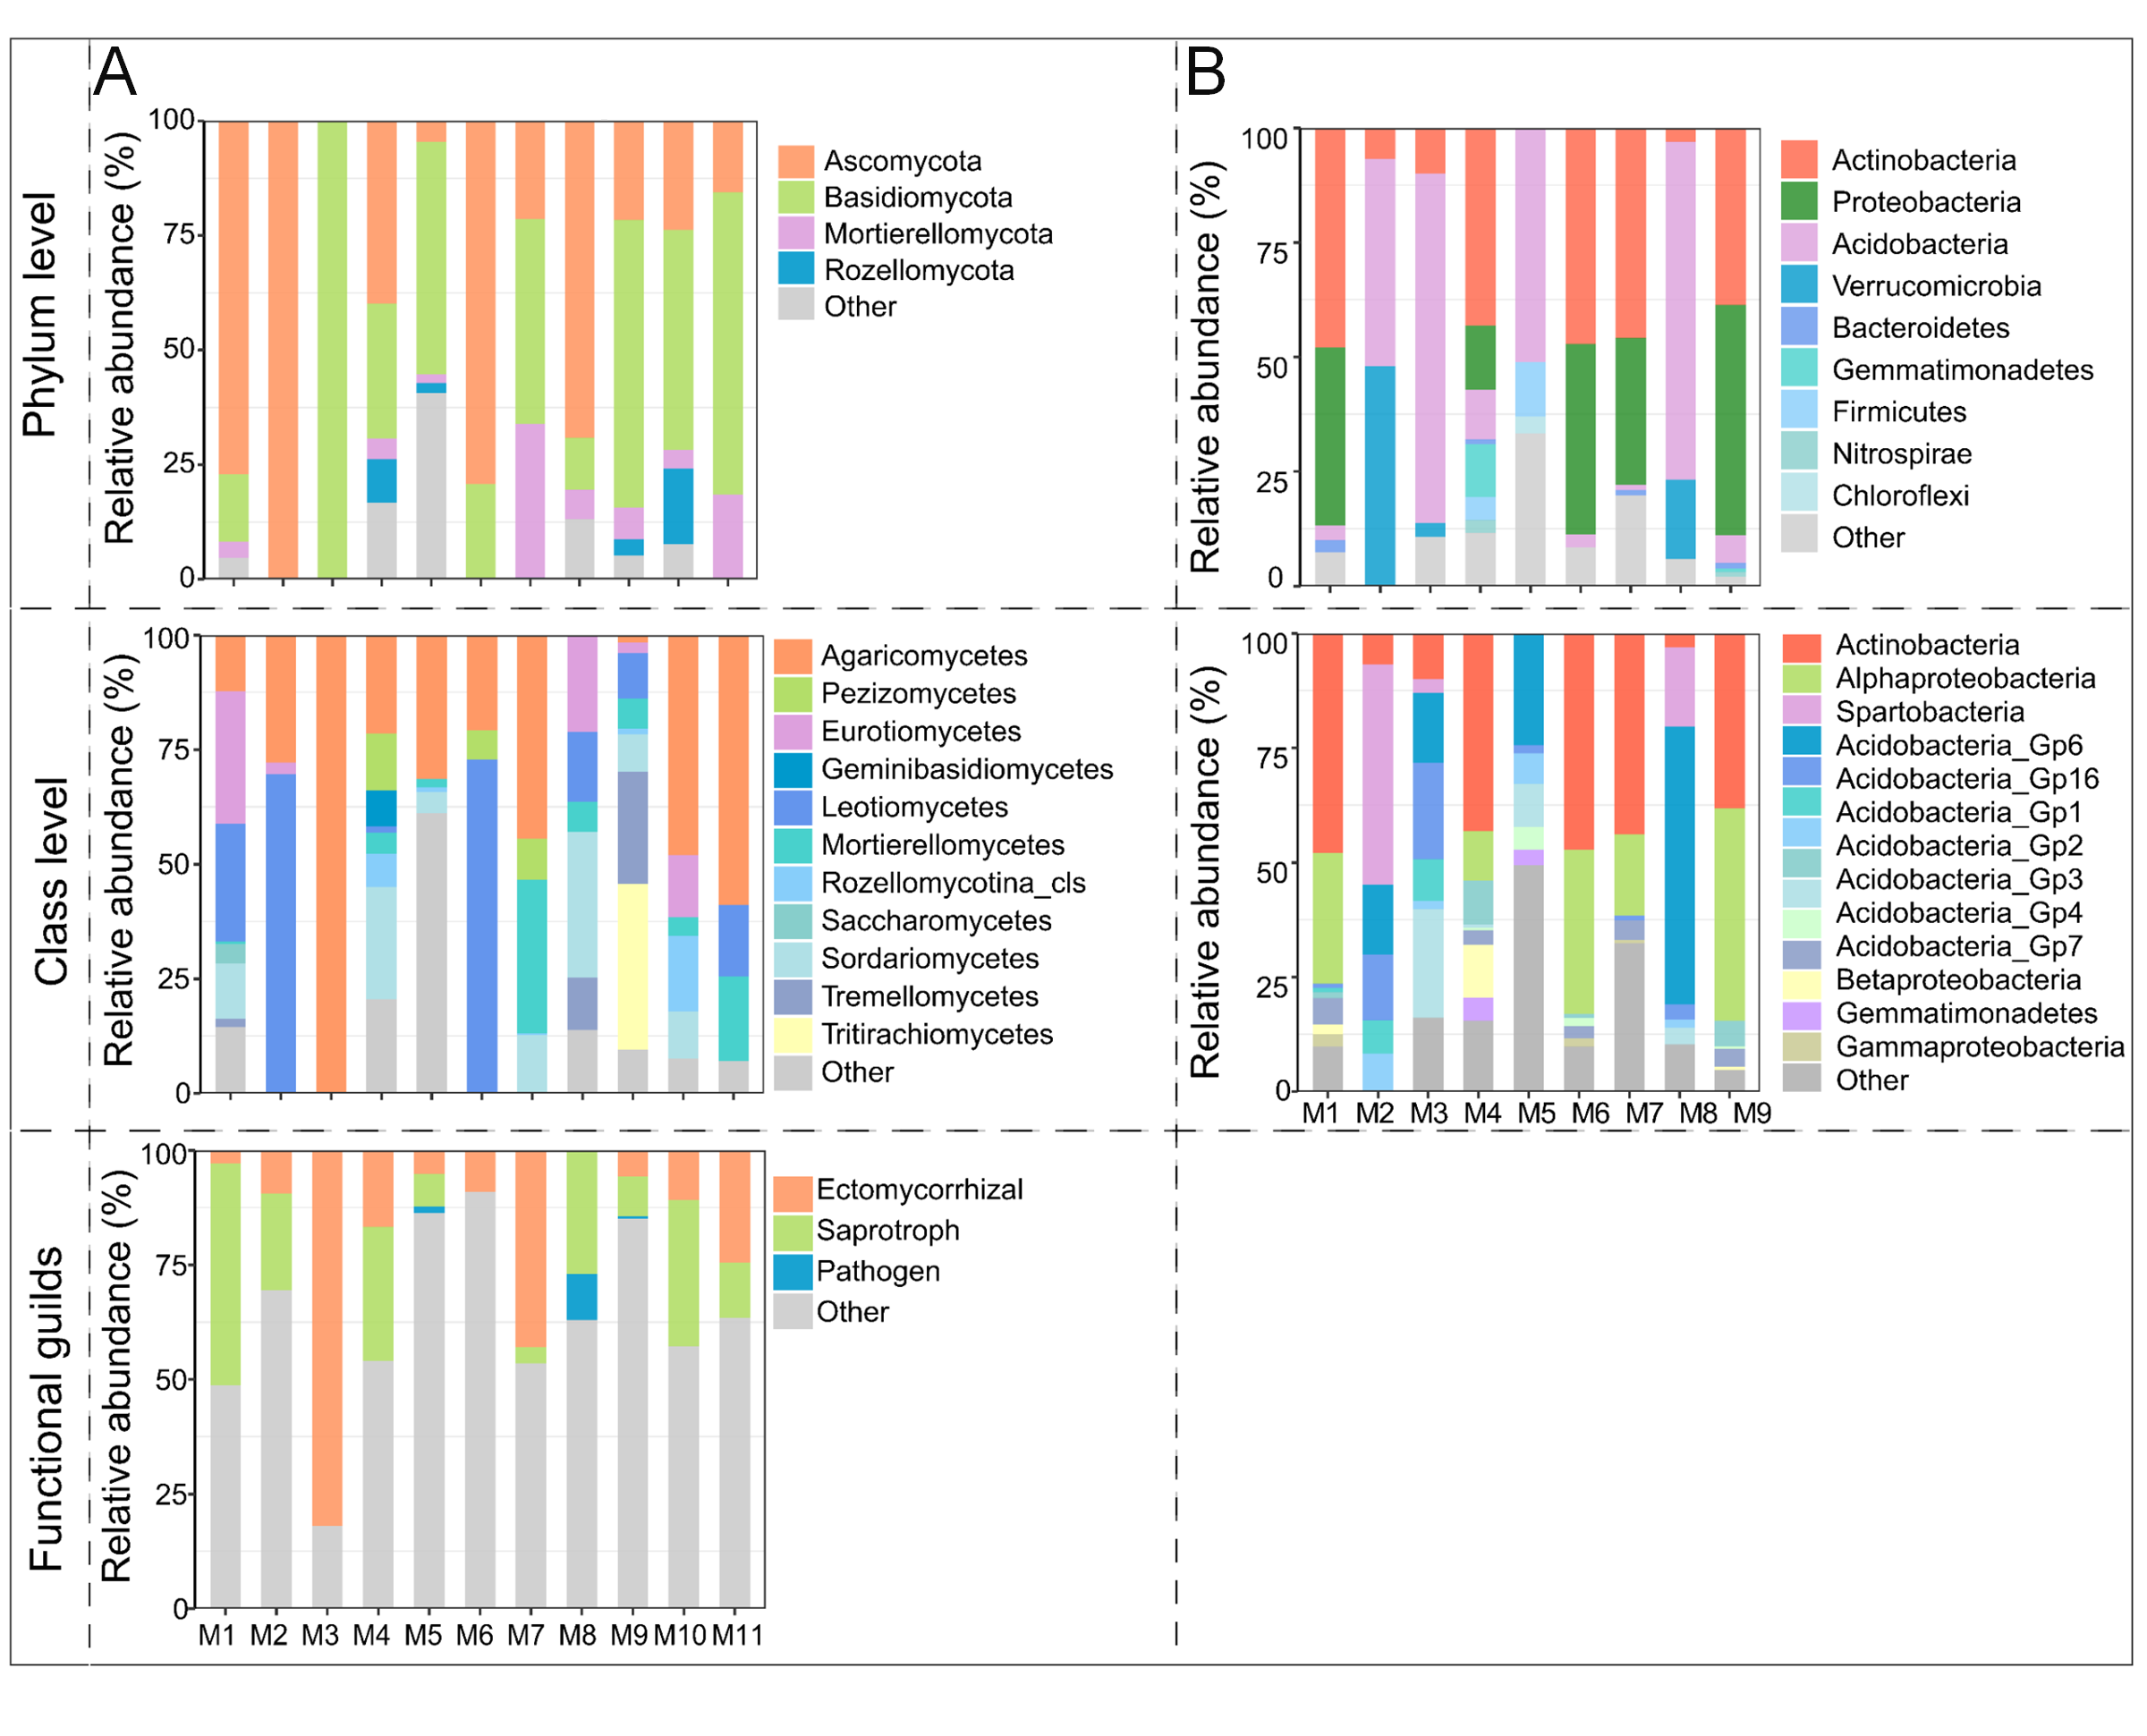

**Figure S2**. Component analysis of different modules. (**A**) Fungal components of 11 modules at the phylum, class and functional guilds levels. (**B**) Bacterial components of 9 modules at the phylum and class levels.

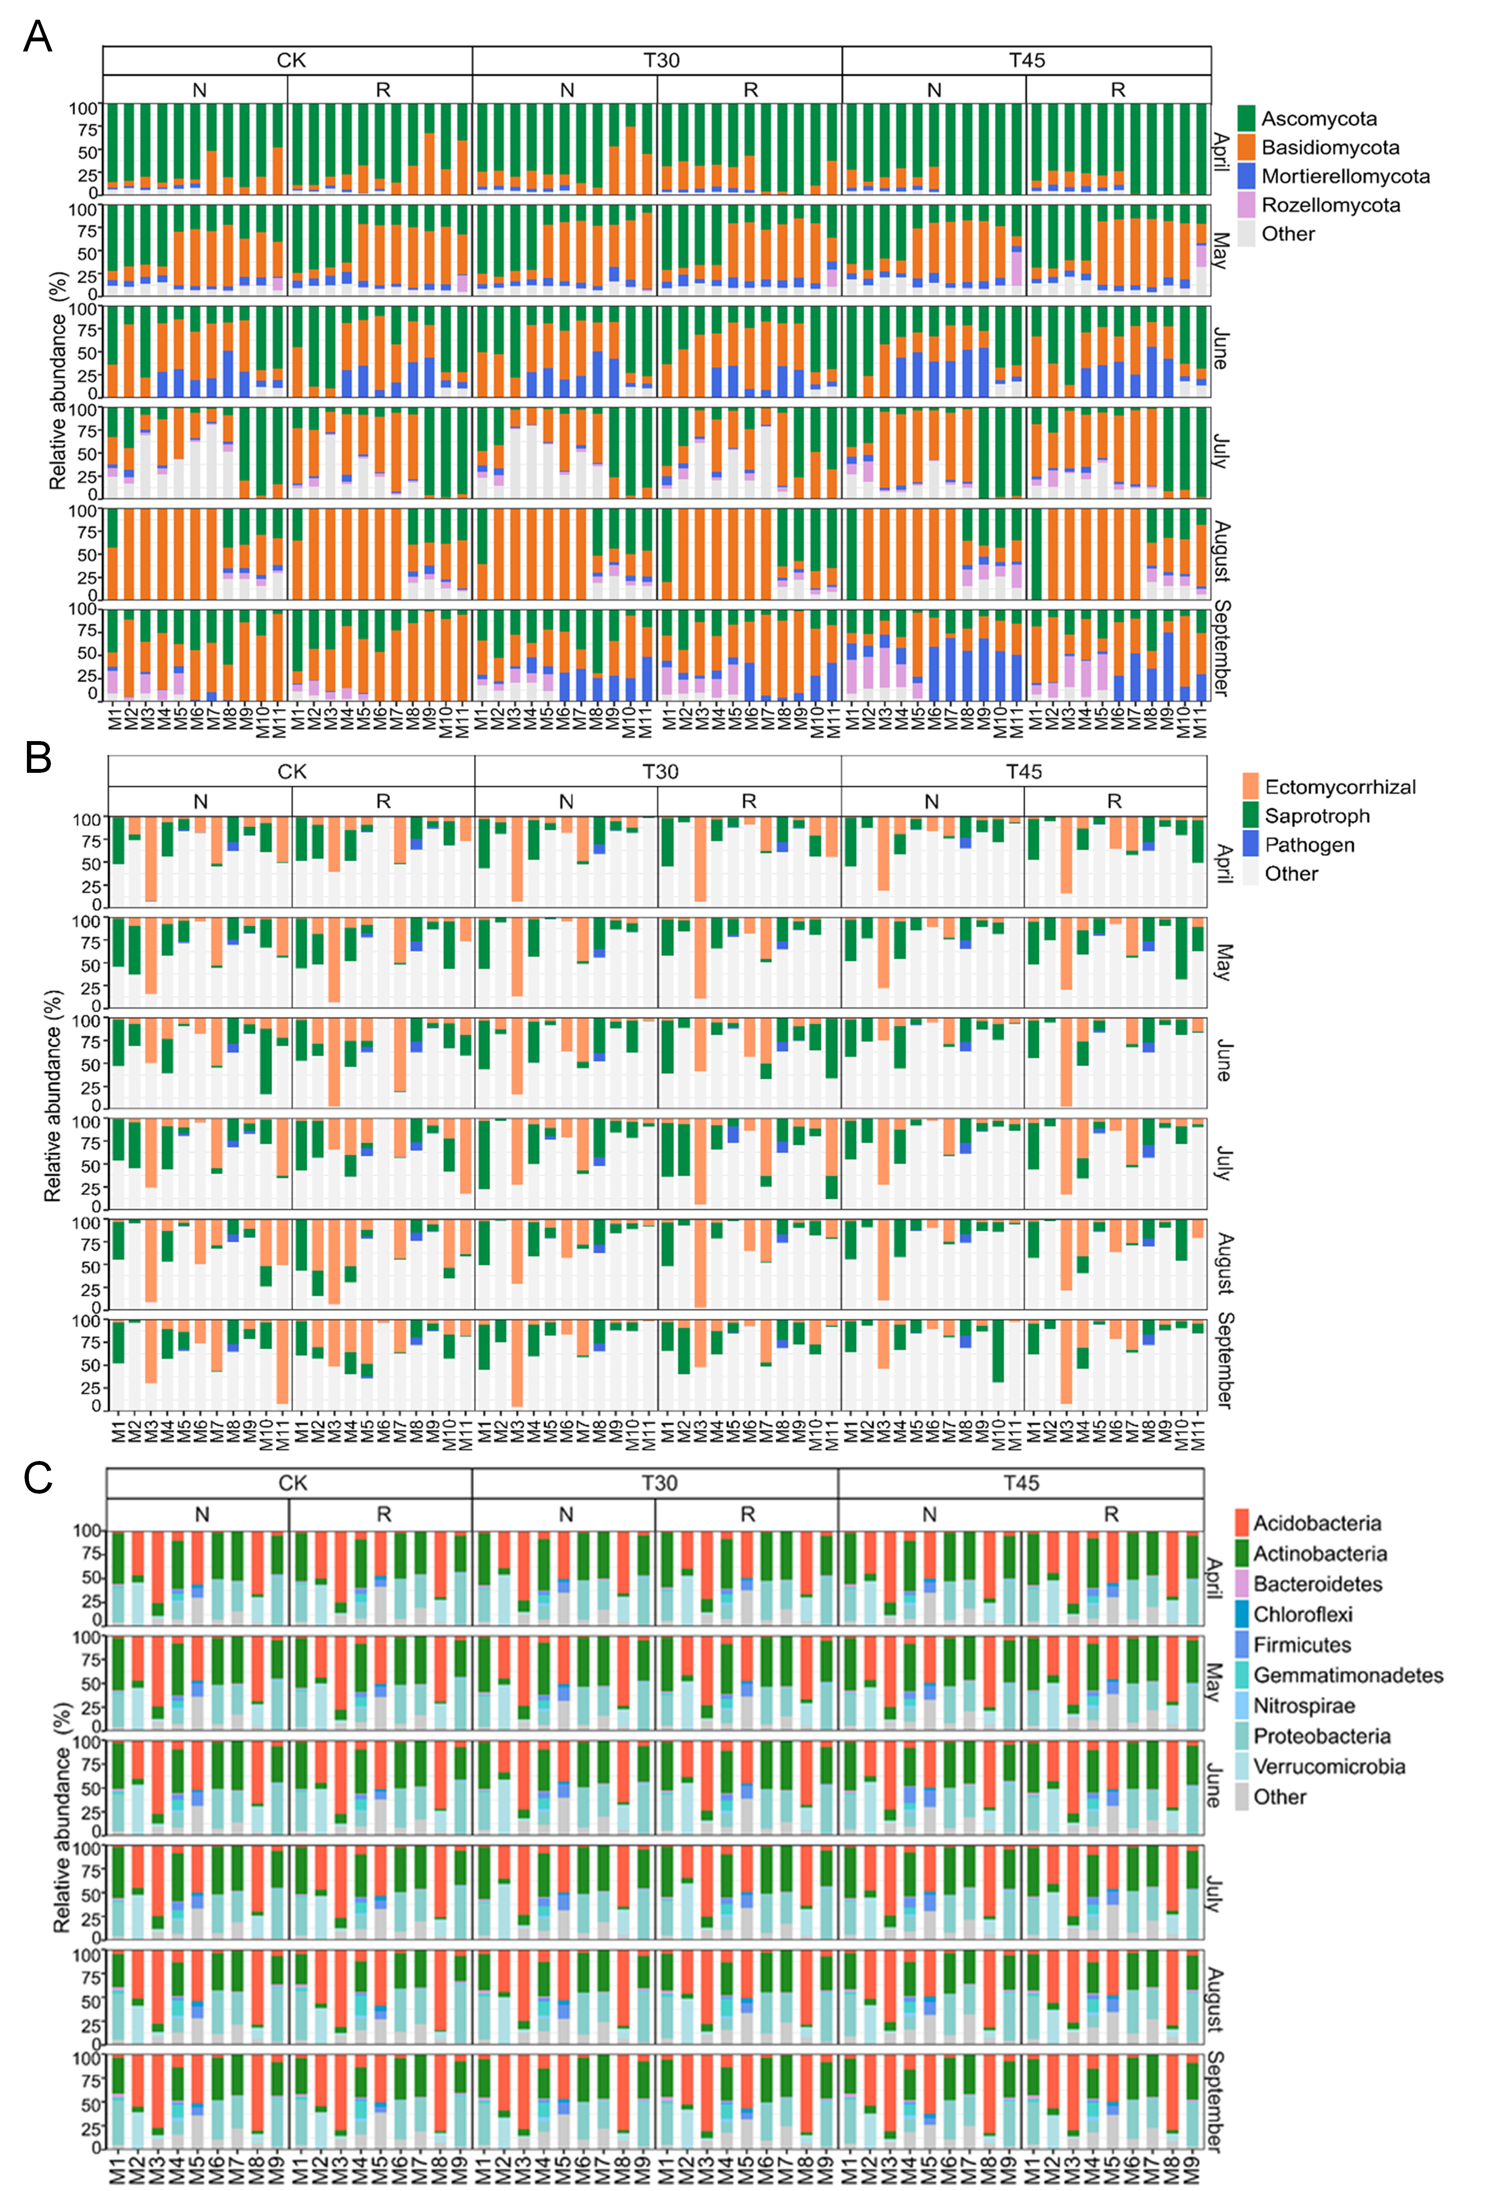

**Figure S3**. Fungal components of 11 modules at the phylum (**A**) and functional guilds levels (**B**), and bacterial components of nine modules at the phylum level (**C**) under the combinations of NP and RP with CK, T30, and T45.